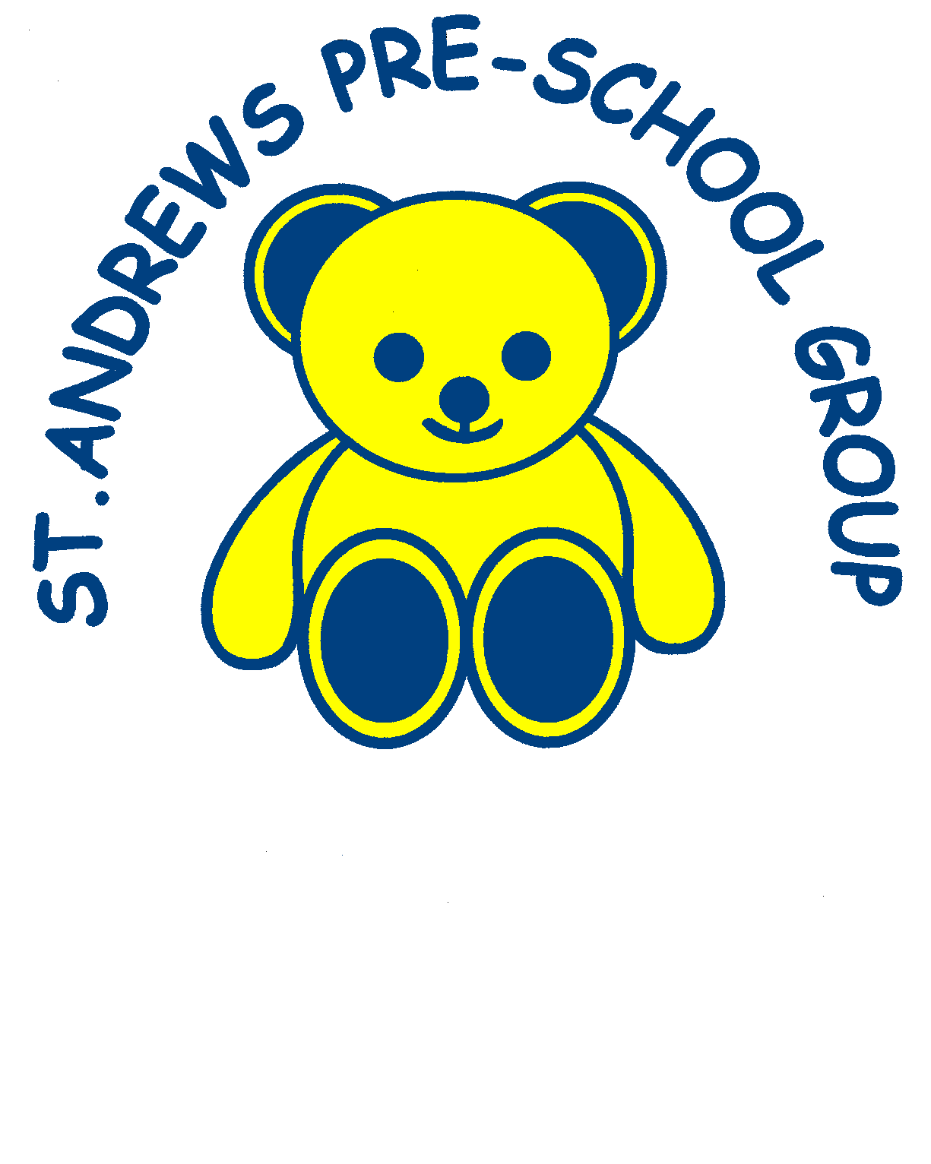
St Andrews Pre-School
Welcome Letter

We would like to welcome you and your family to St Andrews Pre-School. St Andrews
Pre-School has been providing early year’s education in Felixstowe for 40 years. We are registered with OFSTED, who ensure that our premises are suitable and the quality of care and education provided is of a high standard. We are registered to care for children from 2 years old to age 5.

Our aim is to provide a safe, stimulating and caring environment in which children are given opportunities to learn through play, and experiment and explore at their own pace. We endorse inclusion, equality and diversity through our policies and practice, and work with a wide range of multi-agencies to support children and their families.

Opening Times and Sessions (From September 2021)
The Pre-School is open from 8.40am to 3.30pm Monday to Friday, for 38 weeks of the year. Our session times are as follows:
Rising Room

Morning Session 8.40am – 11.40am

Lunch Club 11.40am – 12.30pm

Afternoon Session 12.30pm – 3.30pm

Toddler Room

Morning Session 8.30am – 11.30am

Lunch Club 11.20am – 12.20pm

Afternoon Session 12.20pm – 3.20pm

Fees
Fees are payable in advance. At the beginning of each half-term you will be issued with an invoice for the half-term ahead. Fees must be paid within 2 weeks, by cash, cheque or bank transfer.

Morning or Afternoon Session £13.50
Lunch Club (packed lunch provided by parents) £4 per day
Consumables Charge per session (funded and
non-funded session) £1.50

The term after your child reaches 3 years of age, you will be eligible to apply for 15 hours a week free Government funded places. Some of you may be entitled to 30 hours per week term time only if you meet the criteria set out by Suffolk County Council. You may split these sessions between two settings. Each term you will have the opportunity to change your child’s sessions. Lunch Club can be booked on an occasional basis at any time, subject to availability. Some families in receipt of certain benefits will be entitled to apply for 2 year old funding from the term after their child’s 2nd birthday. This will allow the child 15 / 30 hours a week of Government funded places.

If your child is on holiday or absent from the Pre-School, these sessions must still be paid for. We have a fair and robust policy for dealing with unpaid fees. Late payment of fees may incur a £10 admin fee. Continued failure to pay fees will result in a child’s places being withdrawn.

Childcare Vouchers
We will accept Childcare Vouchers from employers.

Illness and Absence
We ask that if your child cannot attend their session, that you please notify us. If your child has been unwell with sickness or diarrhoea, they must not attend Pre-School for 48 hours after their last attack of illness. This is to stop the spread of infection to staff and other children.

FREE EARLY LEARNING FOR 2 YEAR OLDS – FIND OUT IF YOUR CHILD IS ELIGIBLE

INFORMATION FROM http://www.suffolk.gov.uk

Who can receive the funding?
Funded places will be offered to families receiving one of the following benefits:
- Income Support
- Income-based Jobseeker's Allowance
- Income-related Employment Support Allowance
- Child Tax Credit or working tax credit and your annual income less than £16,190
- Support under Part VI of the Immigration and Asylum Act 1999
- The guarantee element of State Pension Credit
- Working Tax Credit 4 week run on the payment you get when you stop qualifying for WTC.
- Universal credit

When can my child start to receive the funded childcare?
The earliest a child can be funded is the term after their second birthday.

The table below shows the dates of birth and the earliest term which the child could be funded:
A child who turns 2 years between: | Can be considered for a place from the beginning of the:
1 September and 31 December | Spring Term (January)
1 January and 31 March | Summer Term (April)
1 April and 31 August | Autumn Term (September)

How do I apply for the funded places?
If you know which nursery, pre-school, or childminder you prefer, and they have an Ofsted rating of 'good' or 'outstanding', please visit them and take the proof of your benefits with you. This will either be a golden ticket that has been sent to you, or you can complete an online checker by visiting https://www.suffolk.gov.uk/children-families-and-learning/childcare-information-and-support-for-parents-and-providers/guidance-for-parents-and-carers/free-early-learning-for-2-year-olds/ and giving your chosen preschool the code given on completion of your online checker.

To find a childcare provider, you can contact the Suffolk Families Information Service on 0845 60 800 33, or you can find your nearest childcare providers in the Family Services Directory by entering your postcode and searching ' childcare'.

Alternatively, you can visit a children's centre near you. You can find your nearest children's centre by entering your area or postcode in the Family Services Directory and searching 'children's centres'. Take proof of your benefits with you when you visit the children's centre, and a member of staff at the centre will check your benefits and fill in a form with you.

The children's centre will also register you for their services, and give you details of the activities available for you and your child, at the children's centre.

Where are the funded places delivered?
Ofsted registered day nurseries, pre-school playgroups and accredited childminders. You can contact the Suffolk Families Information Service to find an early years provider near you.

How many hours per week are funded?
Up to 15 hours per week for all children and up to 30 hours per week for children who meet the criteria. Your child can start with a few hours and build up to 30.

How long will the funding be provided for?
The funding will continue until your child starts their 15/30 hours of free early education, which is provided the term after their third birthday.

Government Policy

As part of the government policy to improve the quality and range of early education, the Department for Education has created the Funded Early Education Choice Framework. This document explains how children aged 2, 3 and 4 can take up a funded early education place, and what information is available to parents

3&4 Year Funding

All 3 & 4 years olds are entitled to 15 hours free government funding 38 weeks of the year from the term after their 3rd Birthday, some children may be entitled to 30 hours free childcare 38 weeks per year.

Parents of three and four year olds will need to meet the following criteria in order to be eligible for 30 hours free childcare: • They earn or expect to earn the equivalent to 16 hours at National Minimum or Living Wage over the coming three months. • This equates to £120 a week (or c.£6,000 a year) for each parent over 25 years old or £112.80 a week (or c.£5,800 a year) for each parent between 21 and 24 years old. • The upper limit that each parent can earn is £100,000 • This applies whether you are in paid employment, self-employed or on zero hours contract. • The parent (and their partner where applicable) should be seeking the free childcare to enable them to work. • Where one or both parents are on maternity, paternity, shared parental or adoption leave, or, if they are on statutory sick leave. • Where one parent meets the income criteria and the other is unable to work because they are disabled, have caring responsibilities or have been assessed as having limited capability to work. • Where a parent is in a ‘start-up period’ (i.e. they are newly self-employed) they do not need to demonstrate that they meet the income criteria for 12 months. • If a non-EEA national, the parent must have recourse to public funds. • Fostered children are not eligible.

How to apply

- Apply through the government’s childcare choices website.
- If successful you will get a code (an 11 digit number)
- To book a place take the code to your childcare provider with your child’s birth certificate and proof of address.

If you are unable to complete an online checker for whatever reason, you can contact Childcare Choices on
0300 1234 097.

Information
Information is given to parents by newsletter, which is issued every term, this includes details of events, themes the children will be looking at, fundraising and reminders. Information is also displayed on our noticeboard as you enter the Pre-School. Please keep an eye out for messages we send as well as on our Facebook page for useful updates.

All About Me
Pre-school will probably be a new experience for your child, we wish to make the settling in period as easy and happy as possible. You know your child best, so to help us get to know him/her quickly we will provide an ‘All About Me’ booklet. The information you provide in the booklet is very important and will give our team a valuable insight to your child’s likes/dislikes and a typical week at home. This will assist us when communicating and help build good relationships when your child/ren first enrol with us. This information will be used to help plan activities that appeal to your child and will support their learning. Photos of family, friends and so on are a great way to start.

The purpose of this booklet is for us to create a snapshot picture of your child as they are now. It will be placed in their Learning Journey, which is a portfolio of their achievements during the Early Years Foundation Stage (this covers the period from now until the end of the school reception year).

Clothing
Children should come into Pre-School wearing play clothes as out activities often involve a degree of messiness, we like to encourage all children to get involved with painting, sand and water play, crafts and gardening. Please dress children in clothes which enable them to move freely, and also allow them to go to the toilet independently, which we encourage. We have sweatshirts and polo shirts for sale, which are ideal for pre-School. The link to our uniform page can be found on our website. We like to take the children outside for walks and to play, please ensure that they appropriate clothing for all seasons and sun-cream during summer.

Finally
The Pre-school is a welcoming and friendly organisation we welcome help and input from parent/carers and have an open house policy to parents/carers who wish to join in their child’s session. There are plenty of opportunities to get in involved with the Pre-School by helping out at fundraising events. The committee always welcomes new members, please ask for further information. We hope this pack will provide all the information you need to decide which nursery you would like your child to. If you have any further questions, please do not hesitate to contact St Andrews Pre-School email secretary.standrews.preschool@gmail.com with your queries.

Pre-School Policies

It is important that, as parents/carers with children attending our Pre-School, you are familiar with our policies that govern the way in which we run. All of our policies can be found on our website at: www.standrewspreschoolfelixstowe.co.uk

By signing our Admissions form you have agreed that you have viewed our policies.

Welcome to
St Andrews
Pre-School

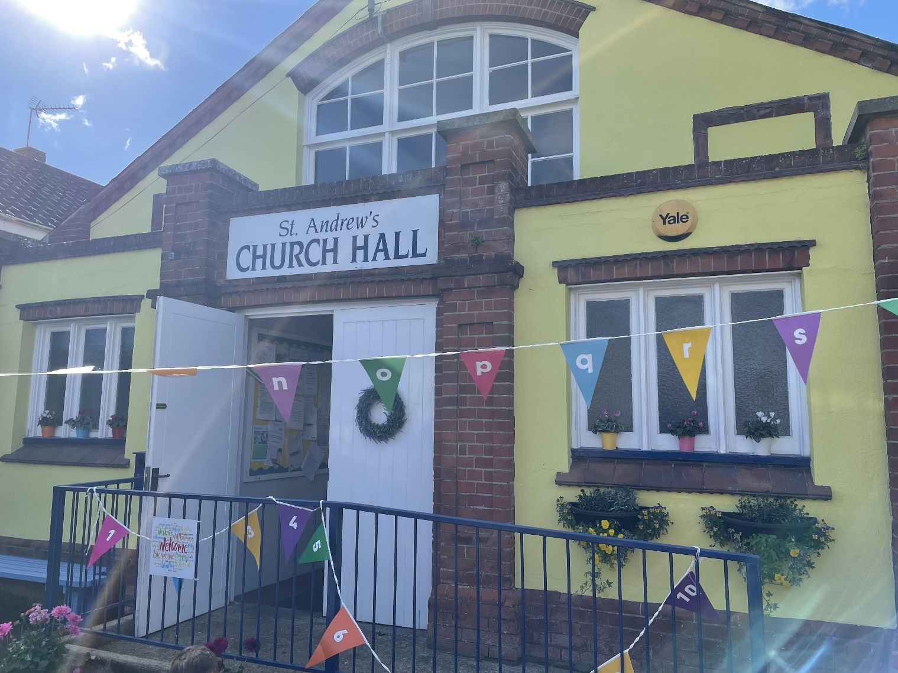

Meet Our Team
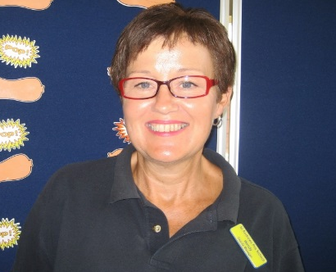

Anna - Manager Meg - Deputy Manager Wendy – Senior
Practitioner

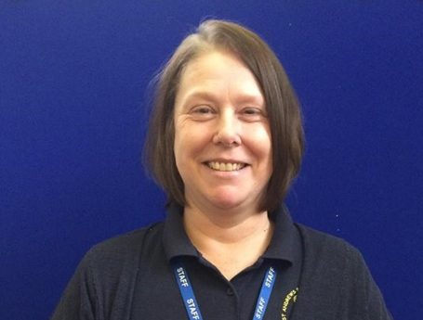
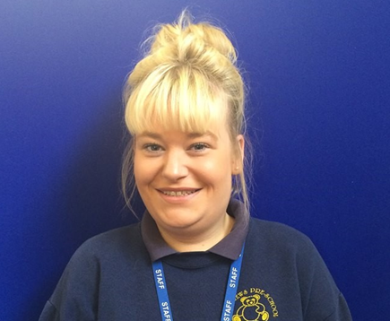

Hannah – Practitioner Chloe - Practitioner Andrea - Practitioner
SENCO

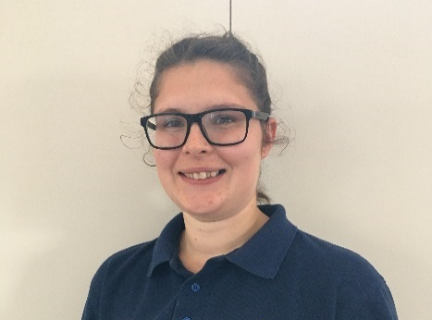

Gemma - Practitioner Ellie – Practitioner
SENCO

Michelle - Finance Aylin - Admin

Staff members and qualifications

Anna Arnold  Manager | Degree in Early Education  certificate working with children & families | Level 6
Megan Emeny  Deputy Manager | Foundation Degree in Early Years | Level 5
Wendy Witherspoon  Senior Practitioner | Certificate in Early Years Practice | Level 4
Andrea Sanders | Diploma for Children and Young Peoples Workforce | Level 3
Chloe Leech | Diploma for Children and Young Peoples Workforce | Level 3
Hannah Gwynaire | Diploma for Children and Young Peoples Workforce | Level 3
Gemma Crane | BA Hons Degree in | Level 6
Ellie Holland | NVQ Children’s Care, Learning and Development | Level 3

This is our Pre-School

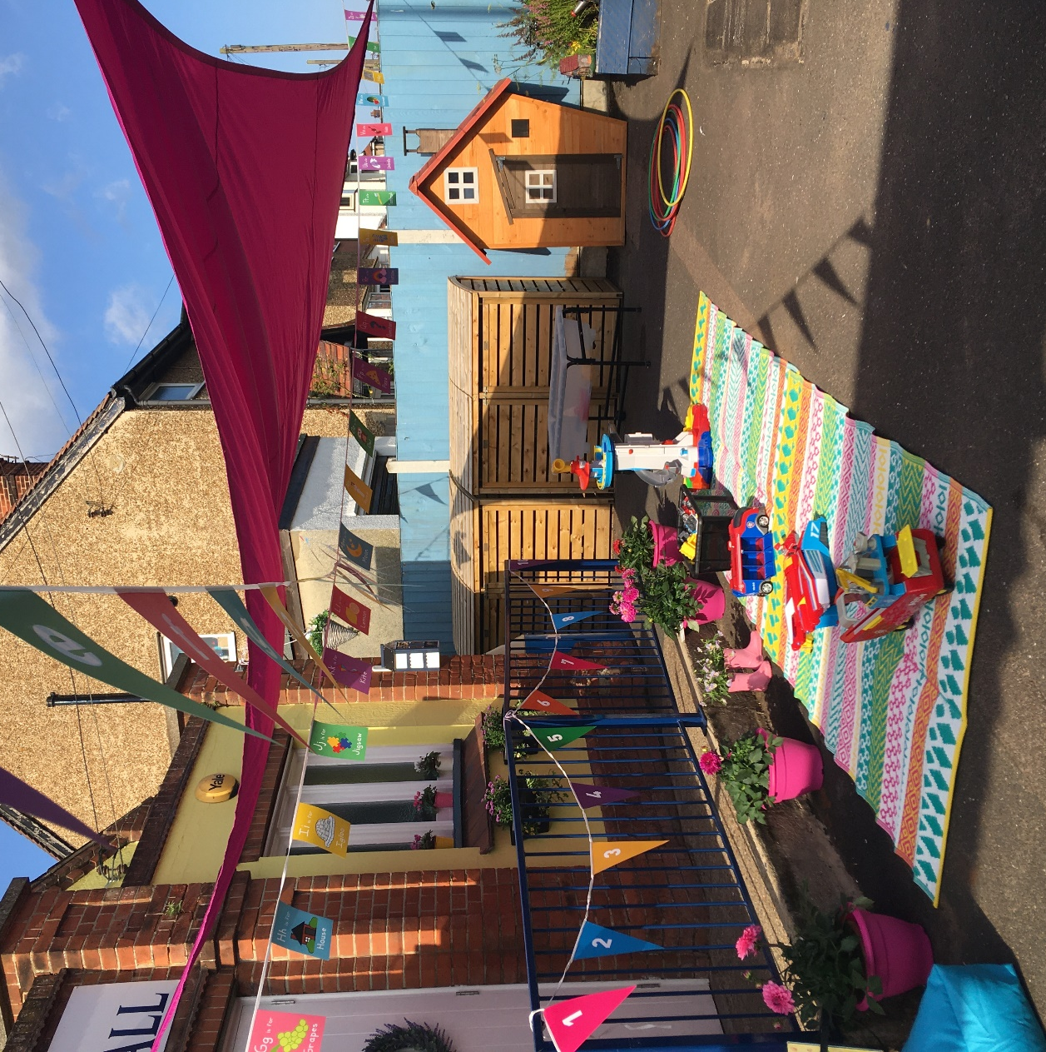

Here are some pictures of our ‘Todds Room’

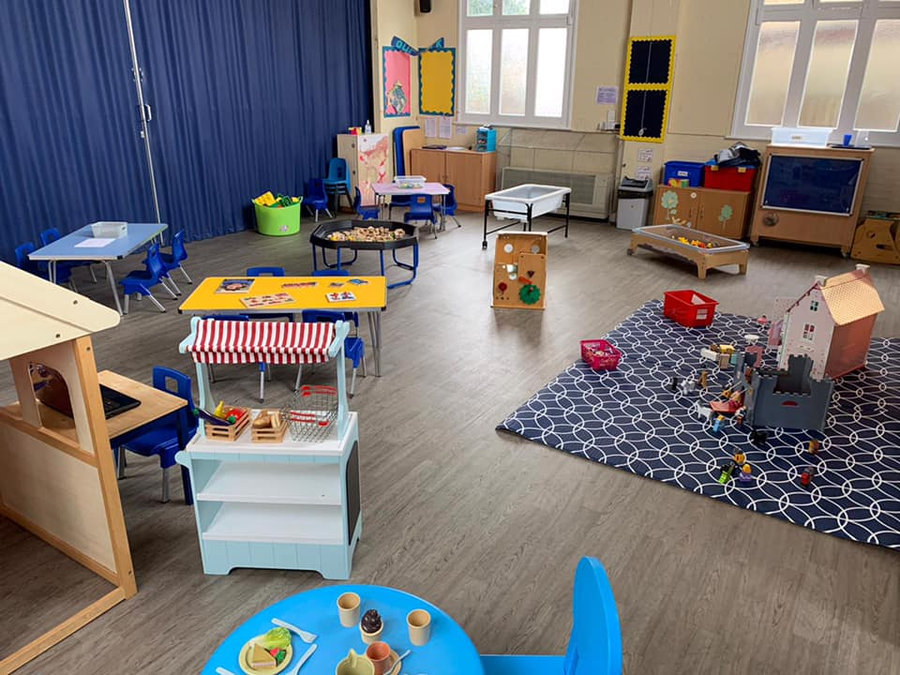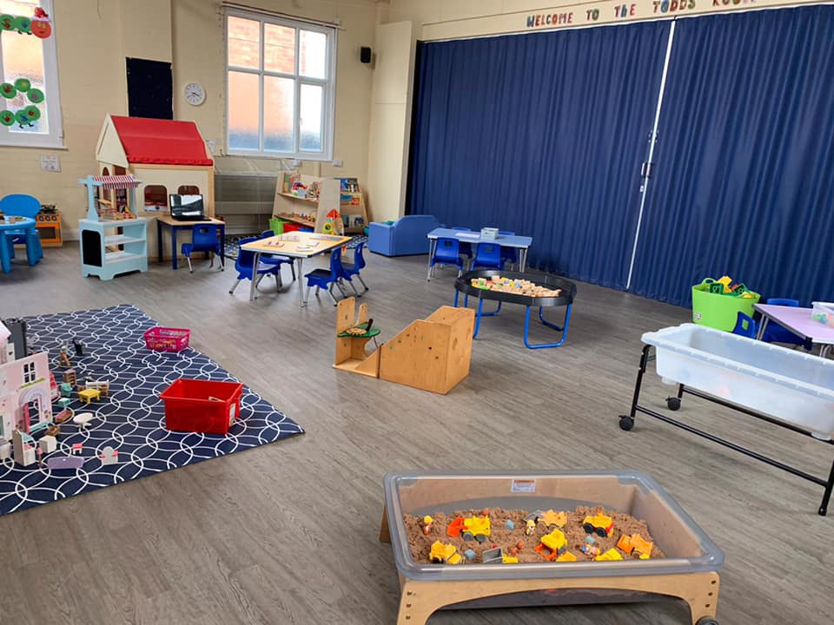
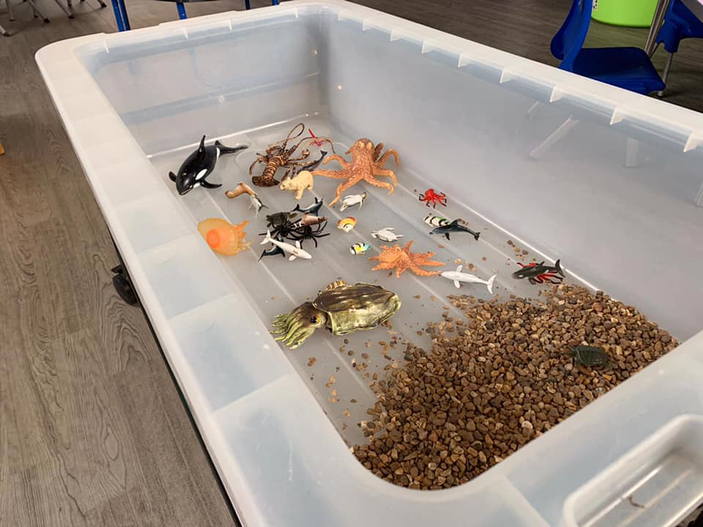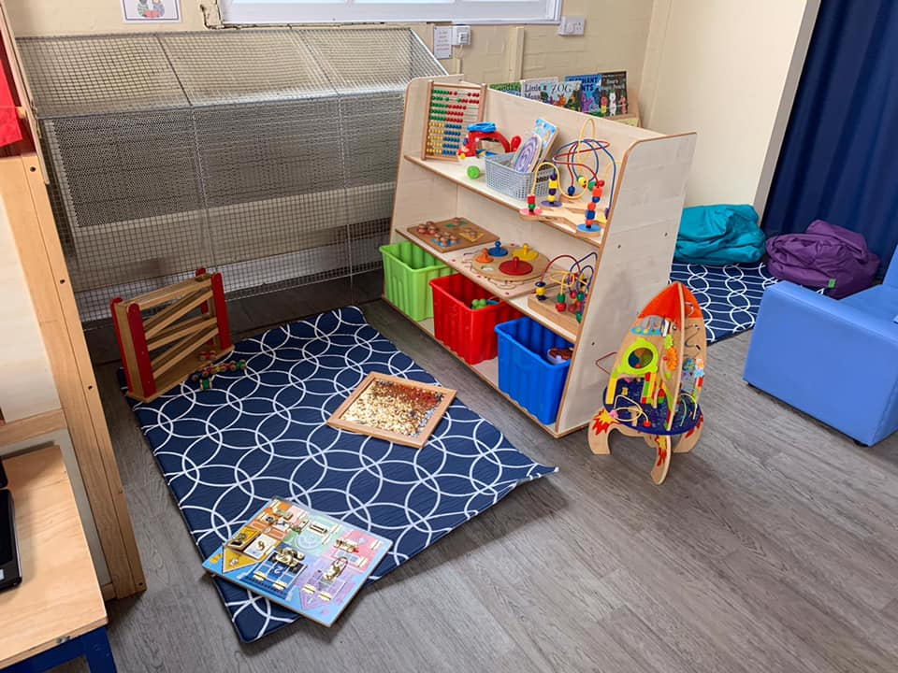

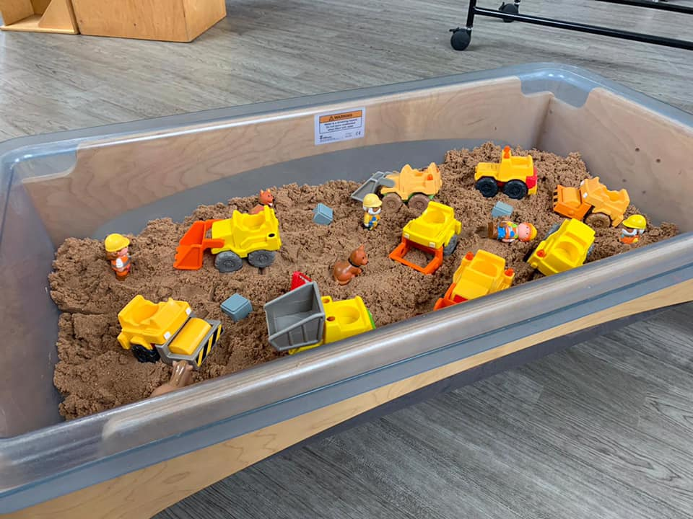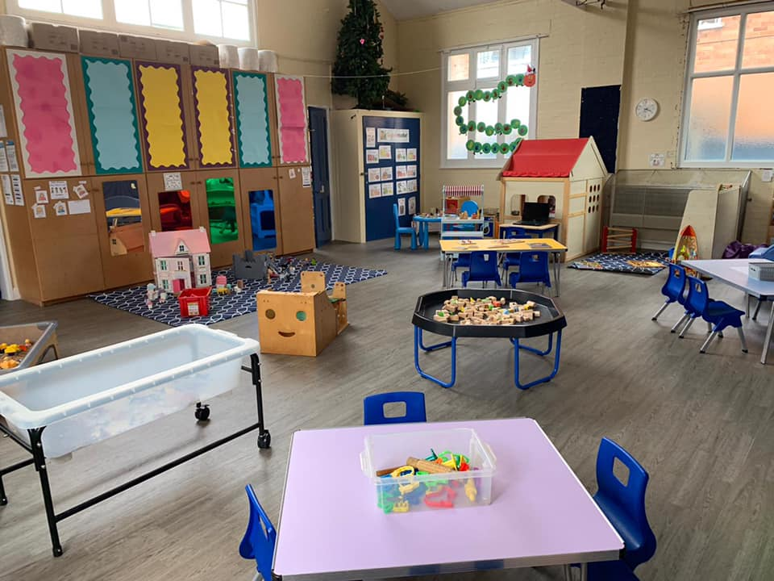

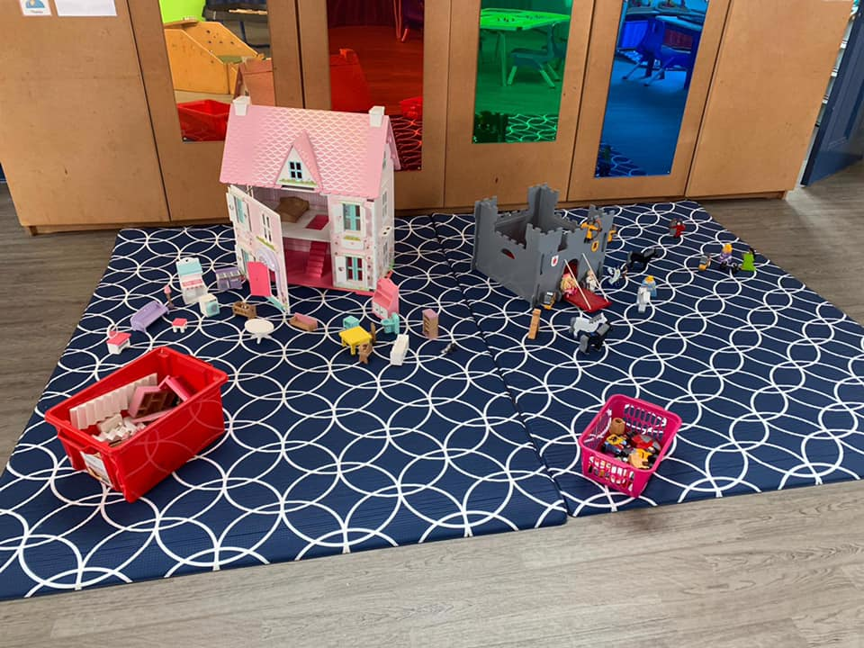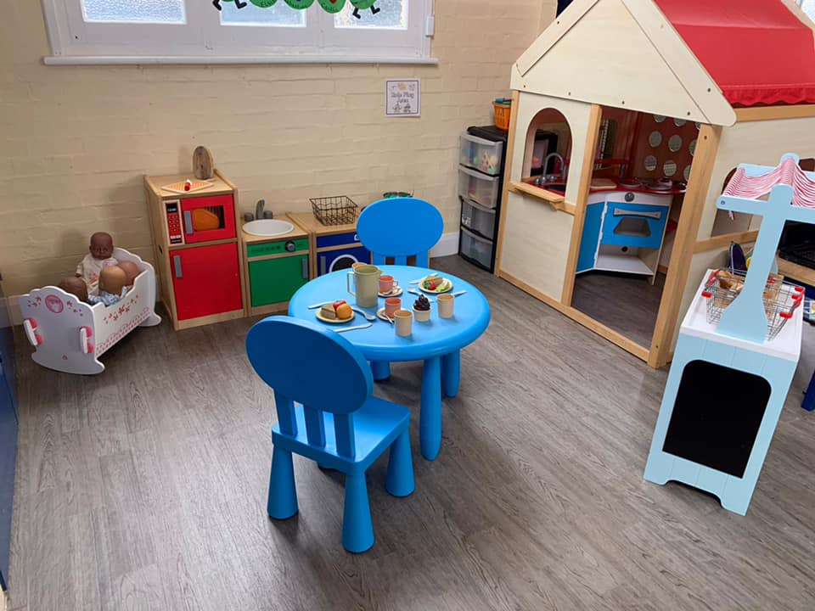

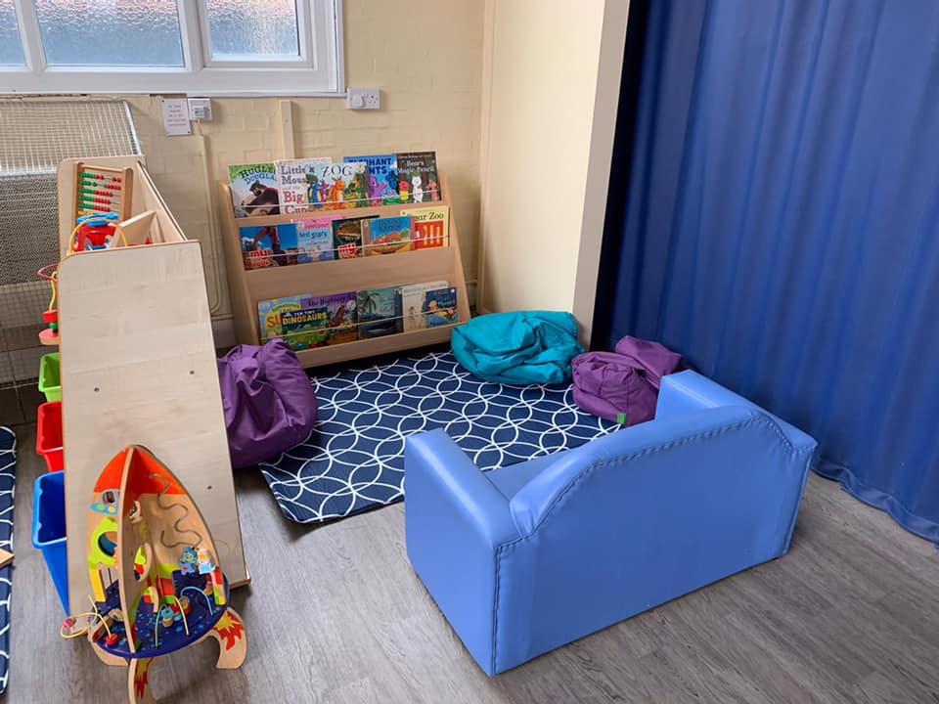

This is our ‘Rising Room’

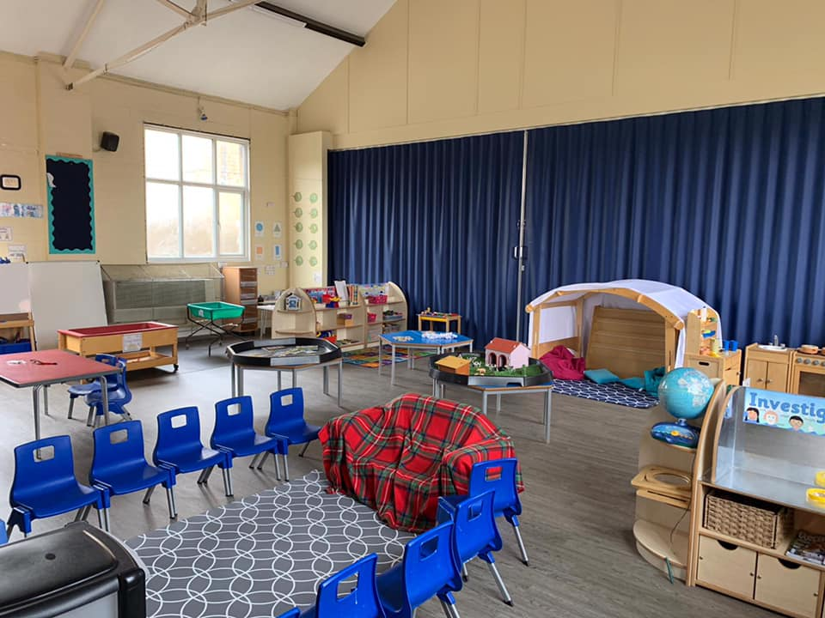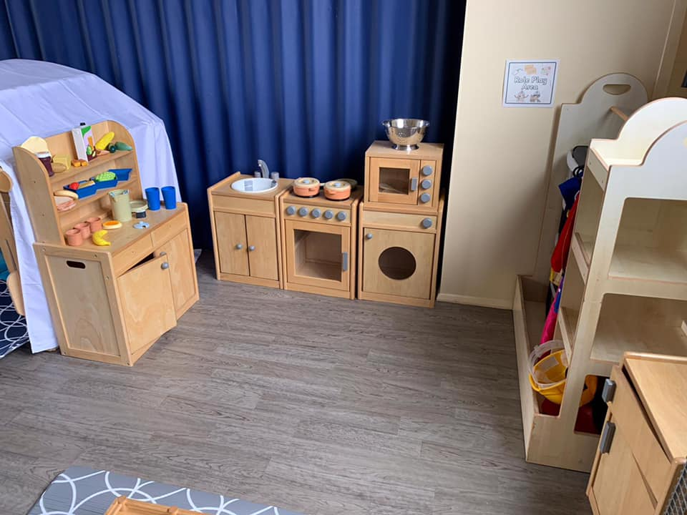

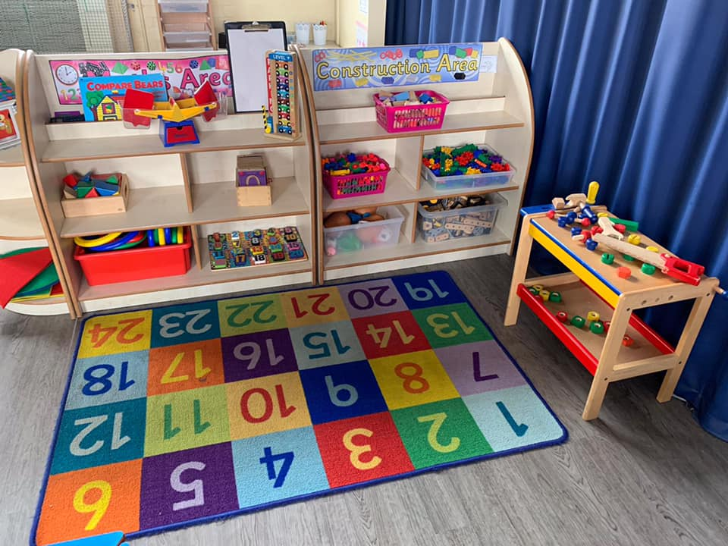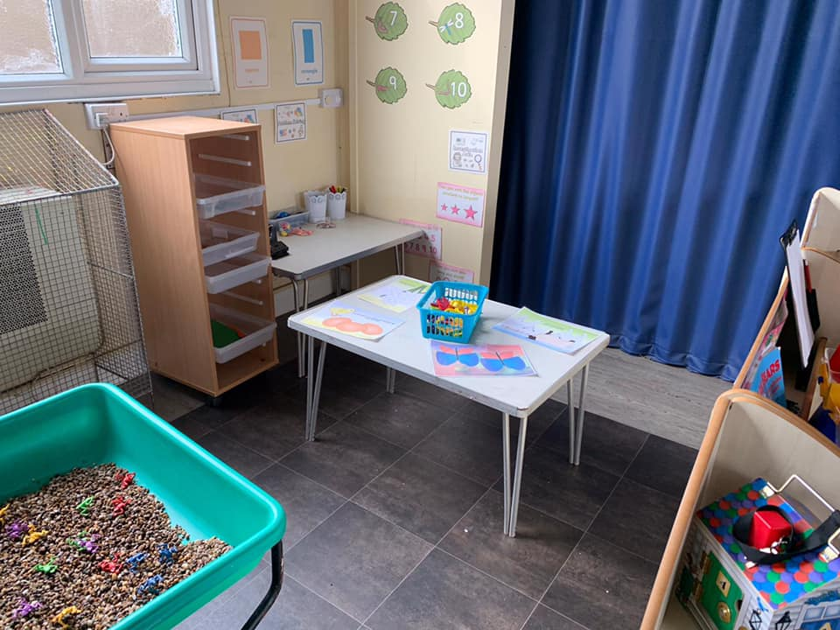

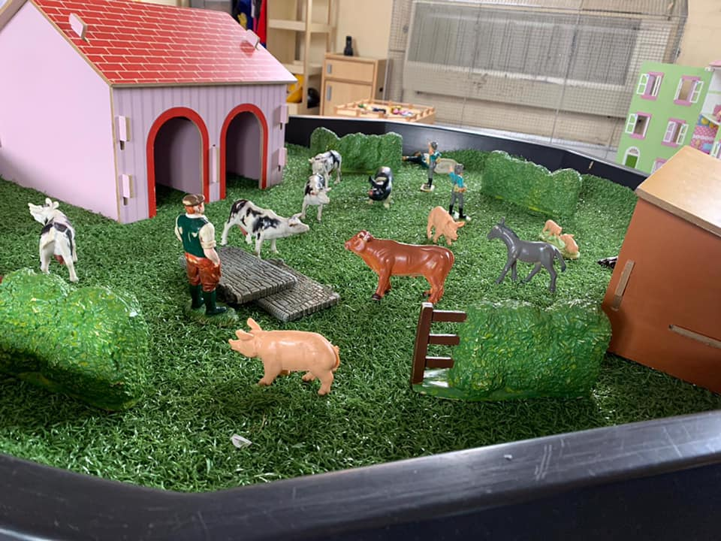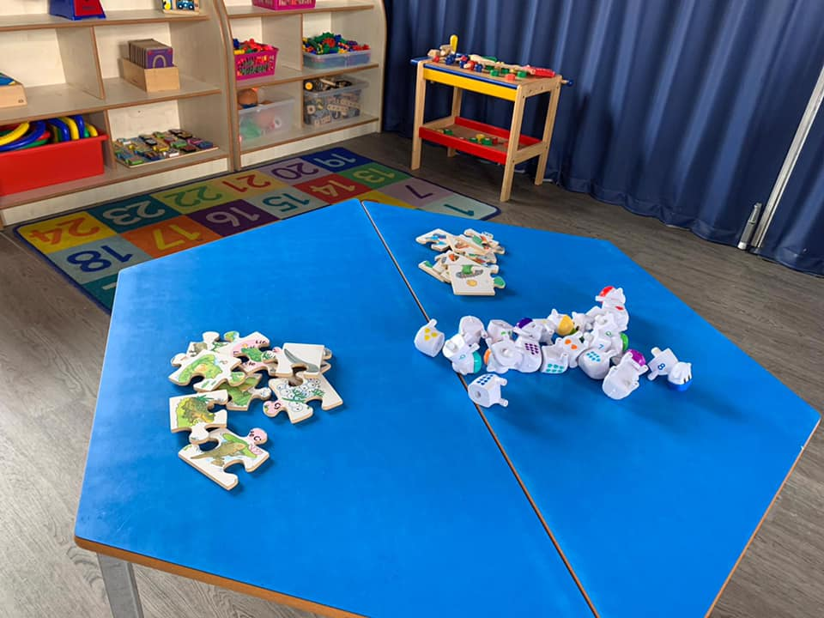
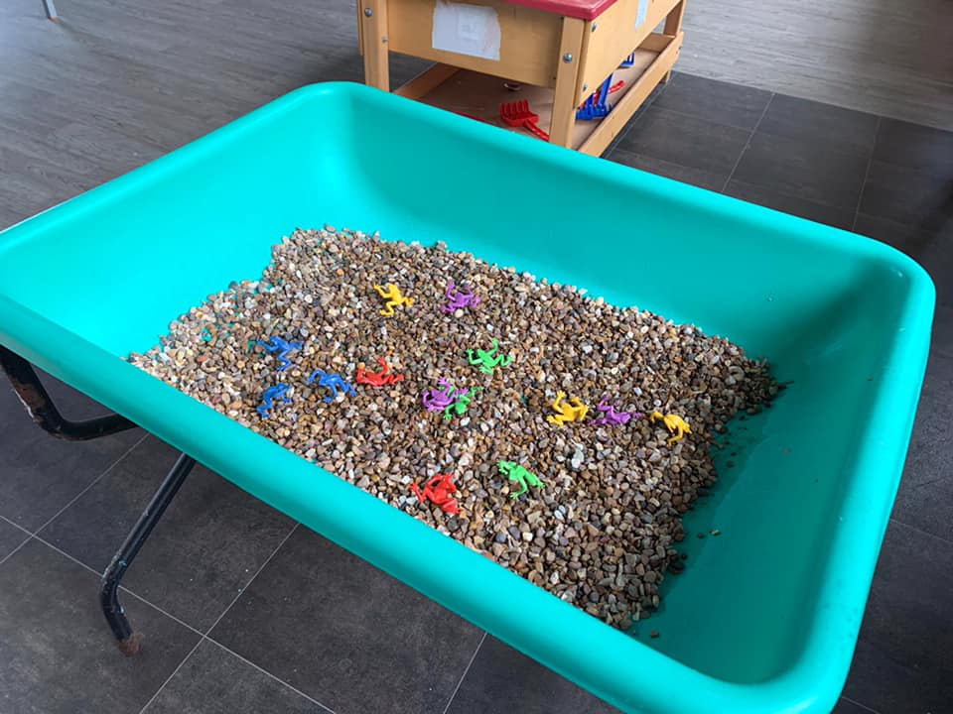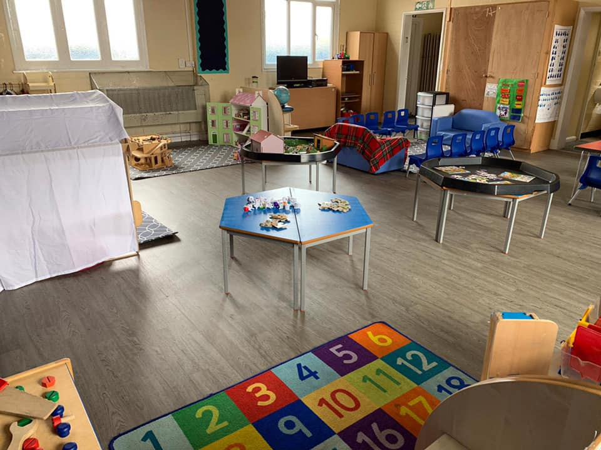

There are lots of things to do at Pre-School…

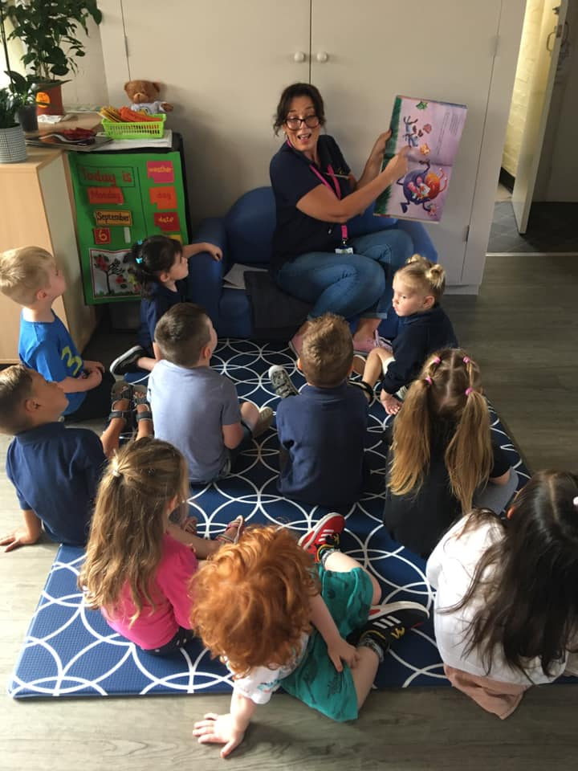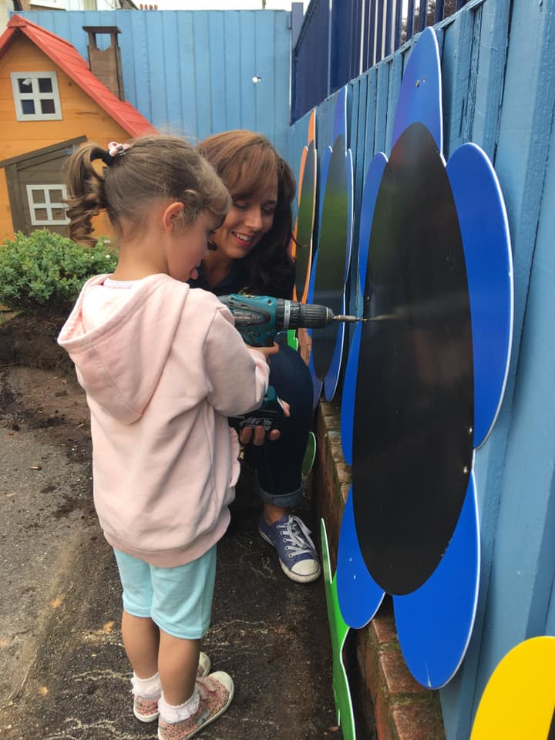

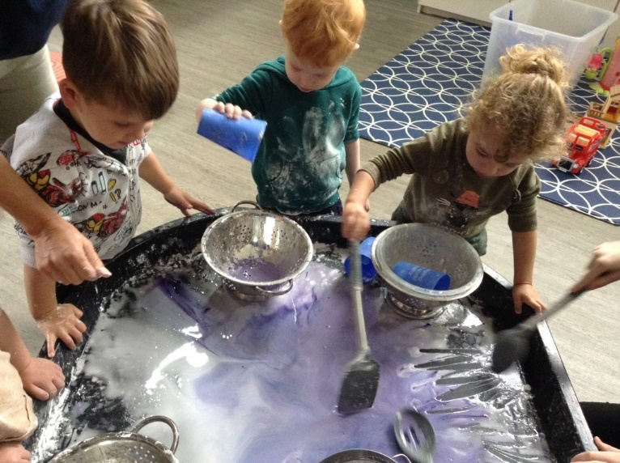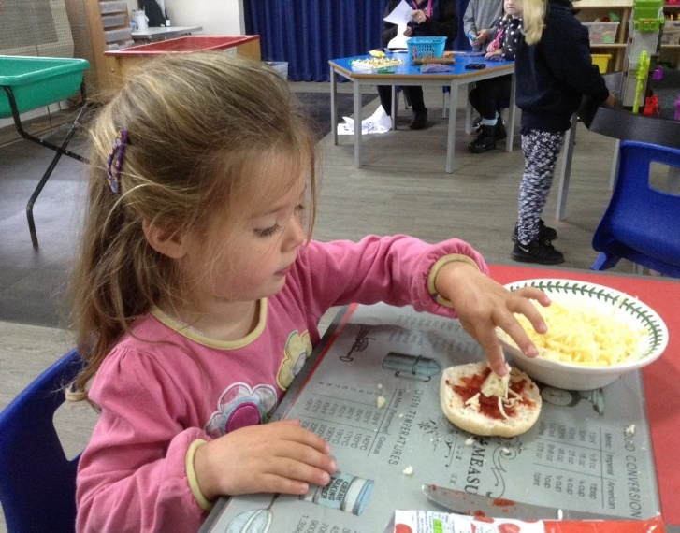

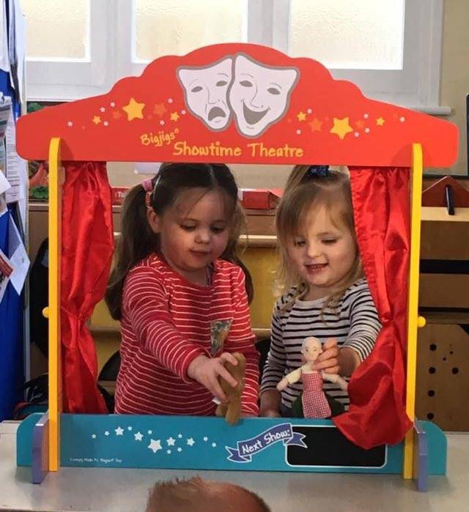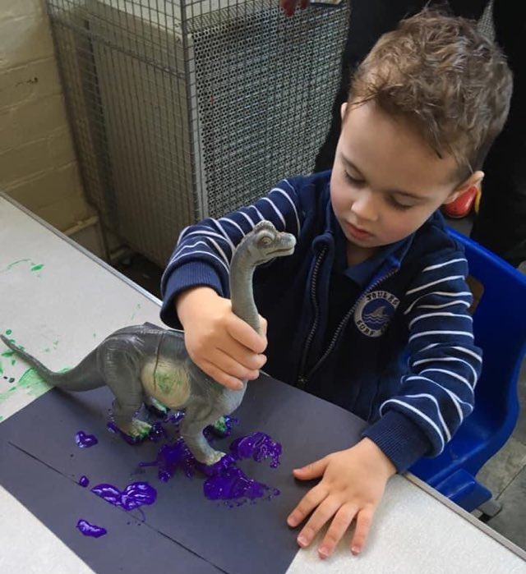

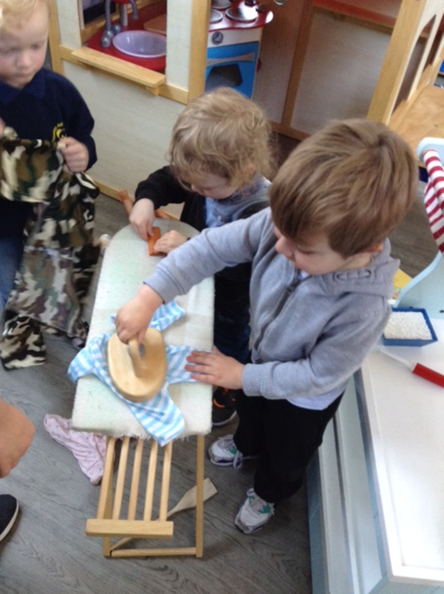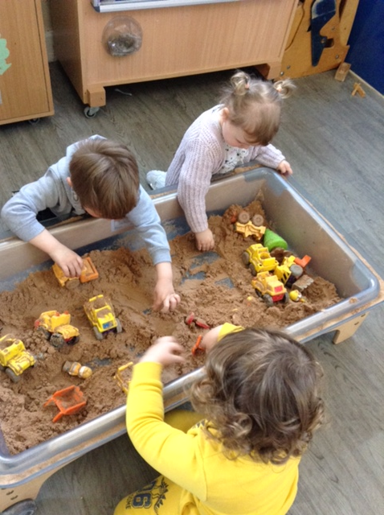

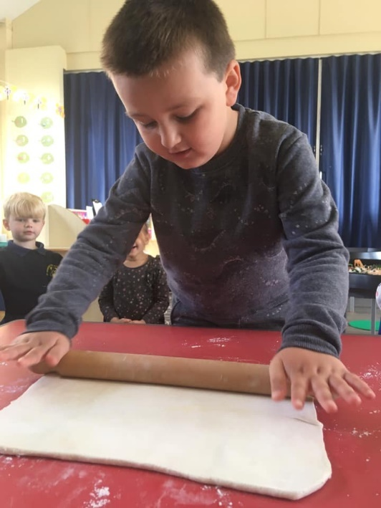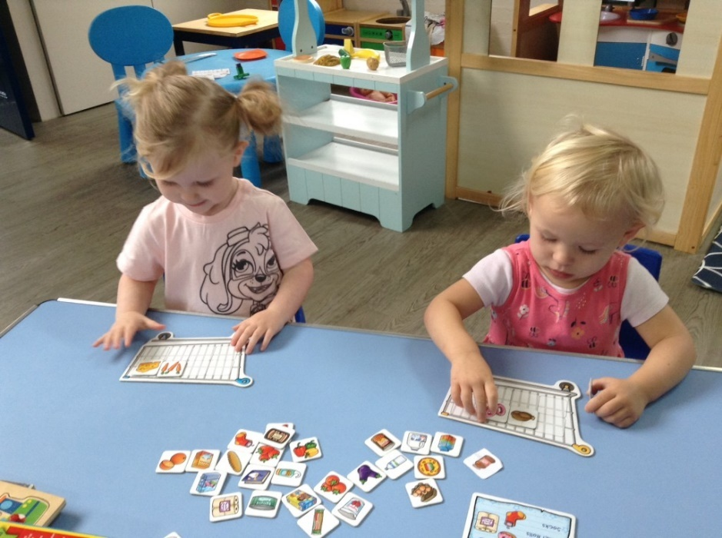
When it is warm and sunny, we go to the beach

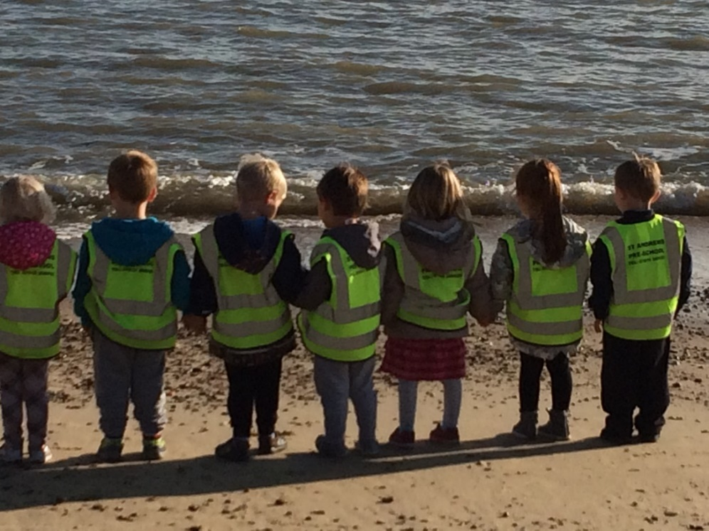

In our rising room we go on lots of fun trips….

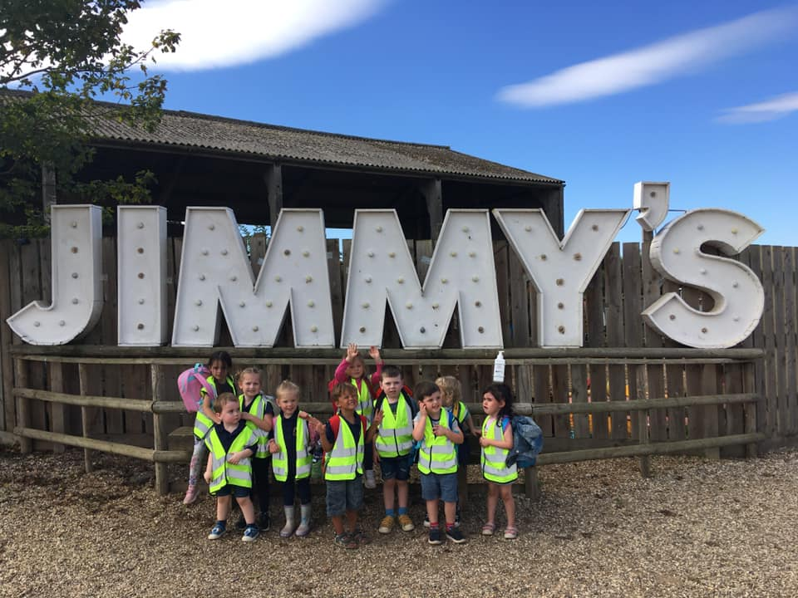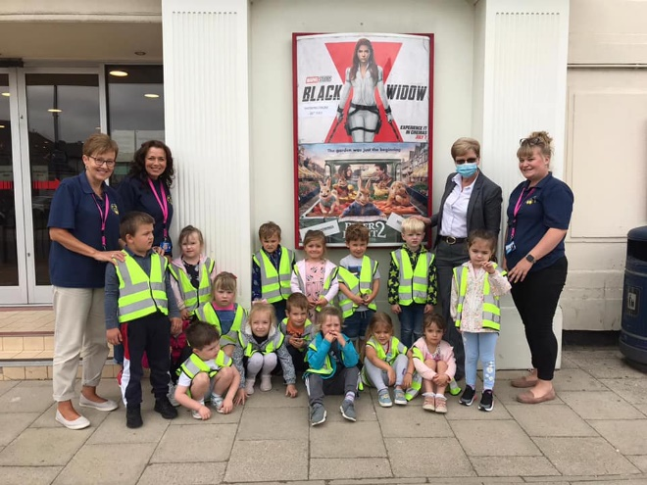

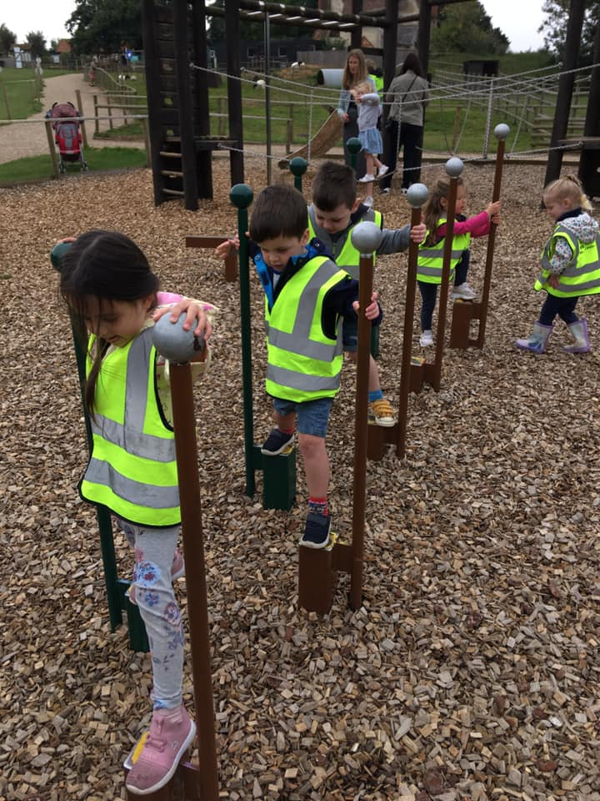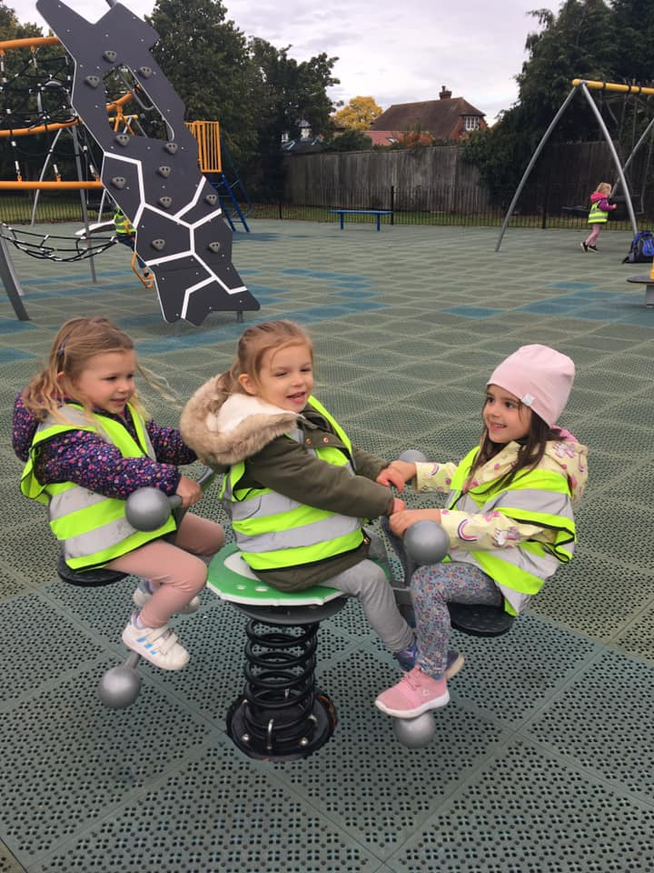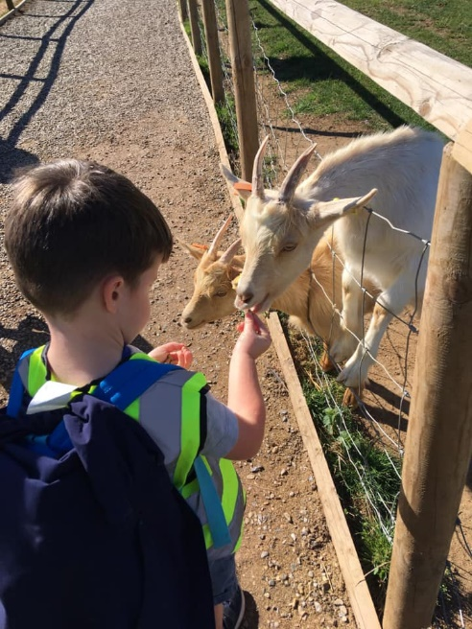

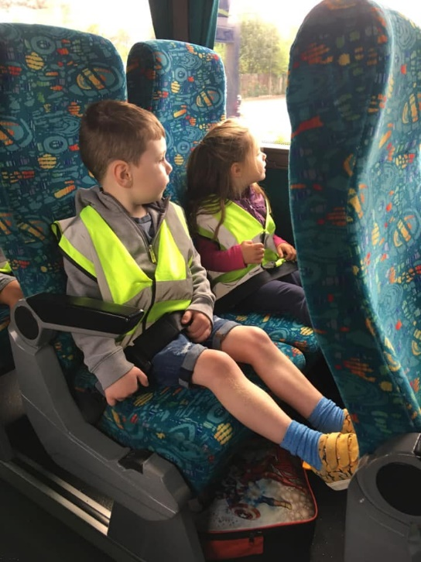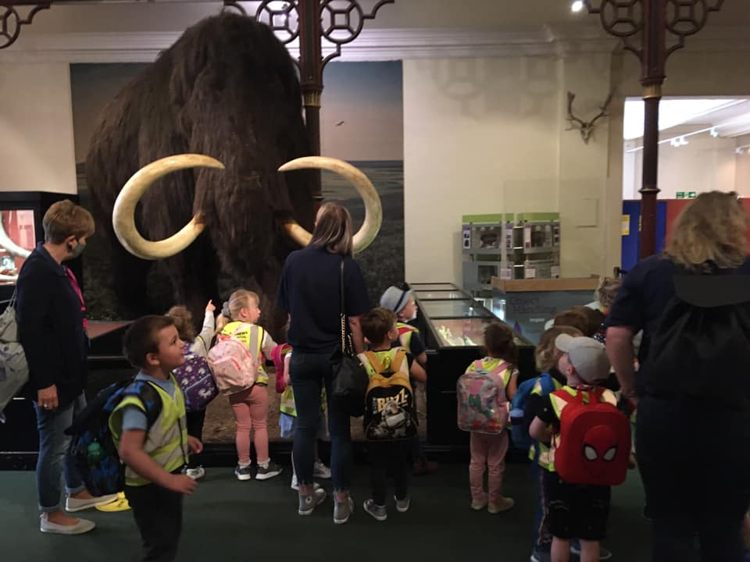

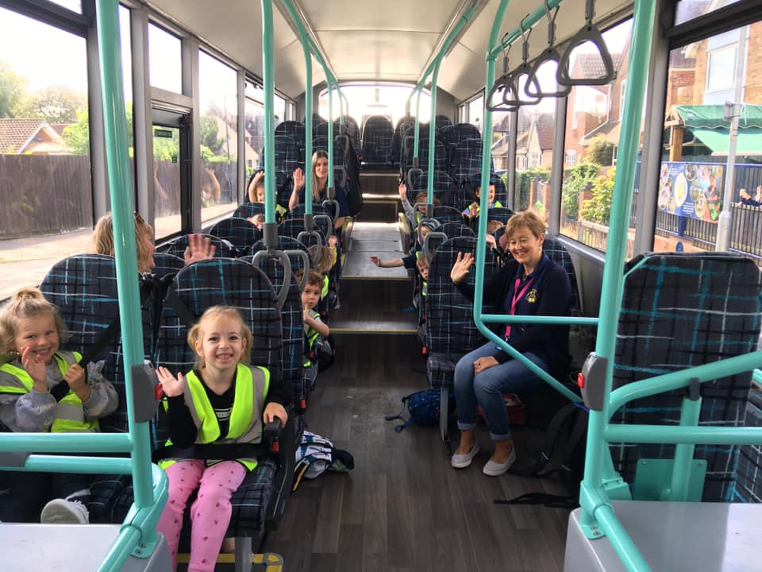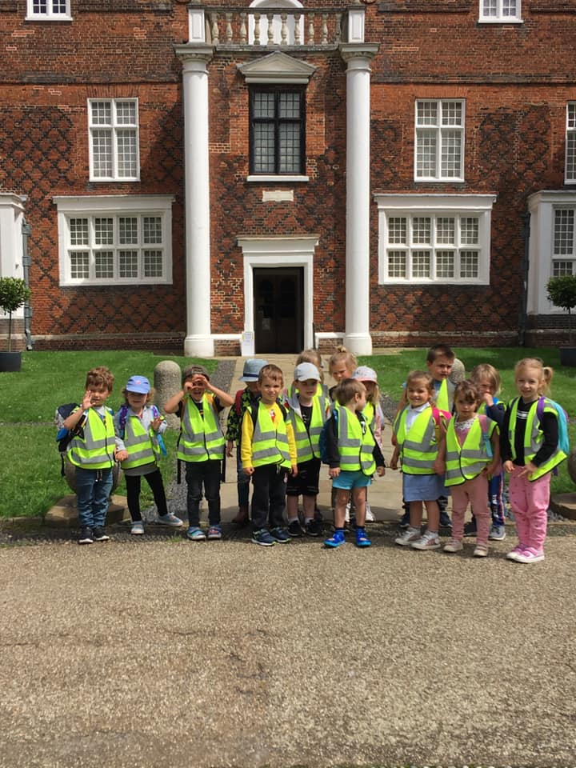

Sometimes we have people come to visit us

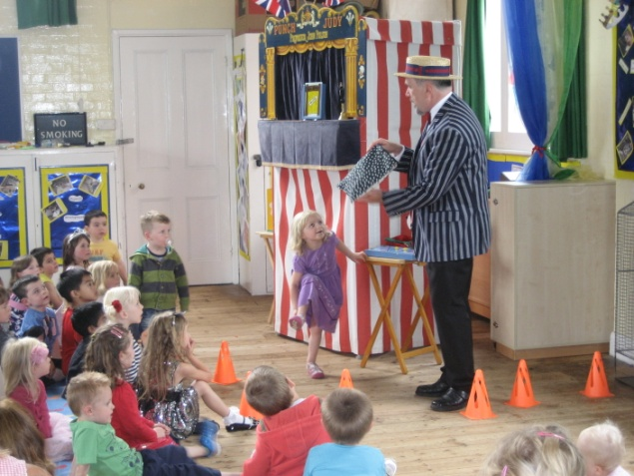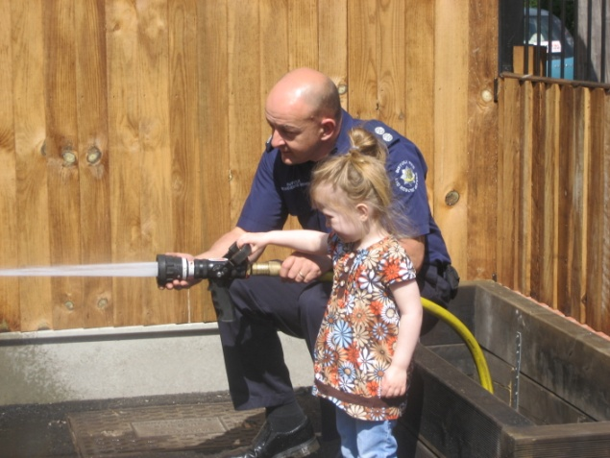
We have visits from some very different pets
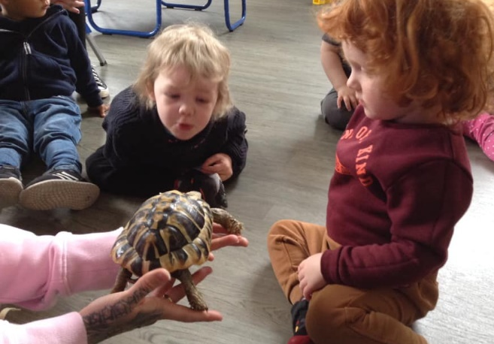
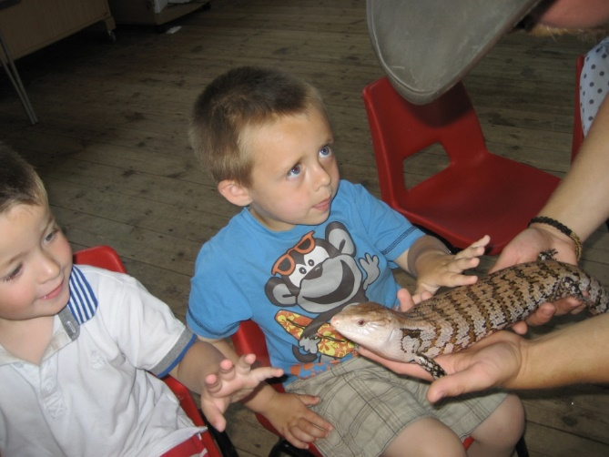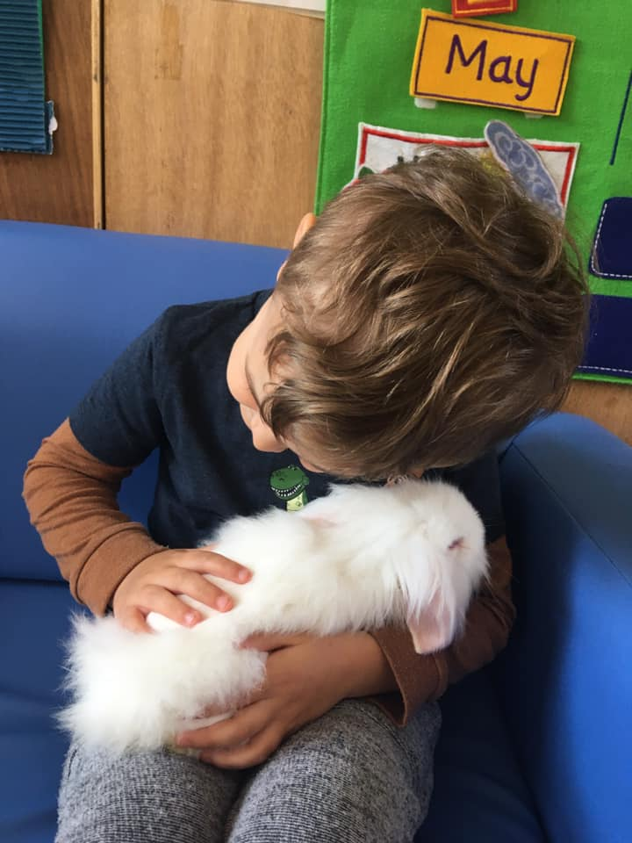

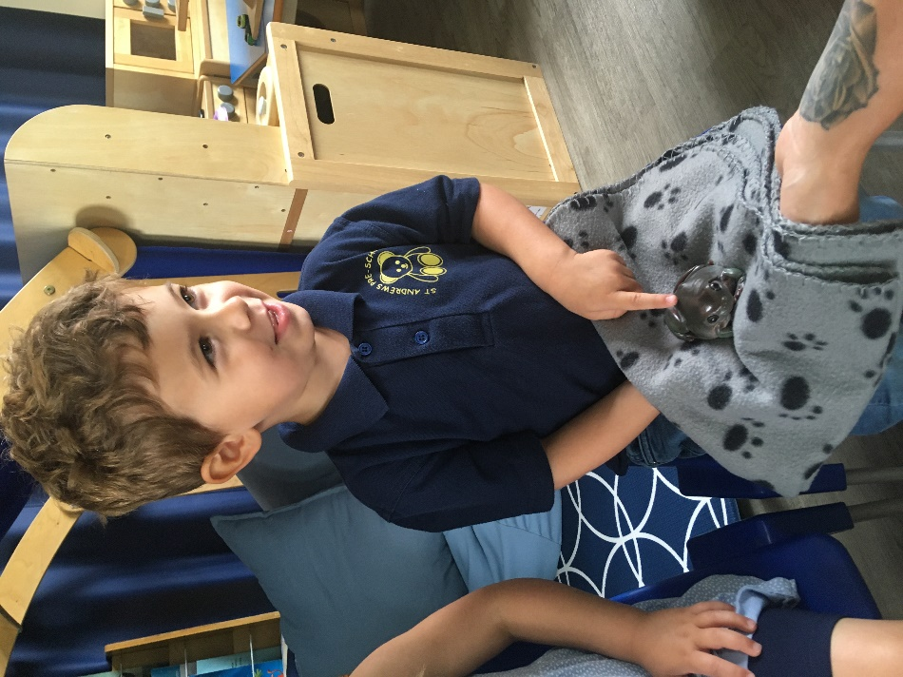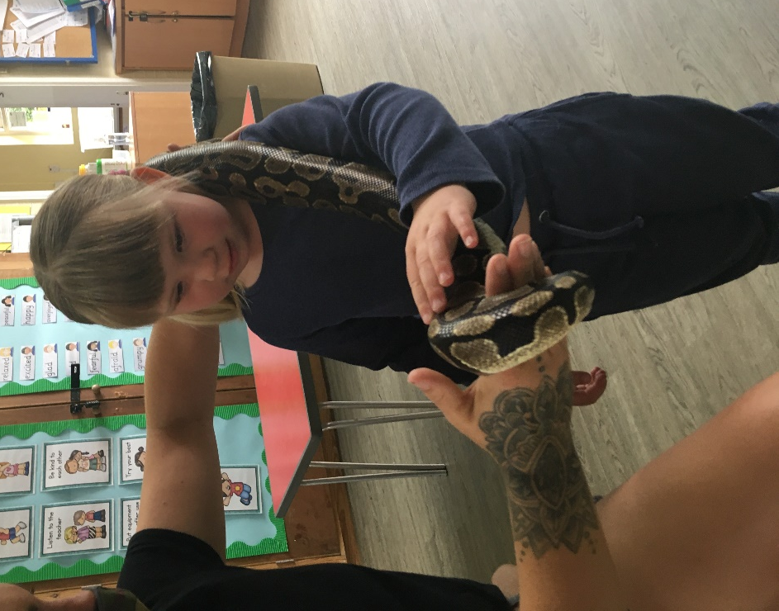

Pre-School Events

Thank you very much for showing an interest in helping out with Pre-School events. This is a great way to get involved with the Pre-School, get to know other parents and to help us raise much-needed funds to buy all the latest equipment for our children to use while they are at St Andrews.

We hold a number of events throughout the year. Some of these are held during a session for the children to join in with; these events include the Christmas party, sponsored obstacle course and sports day.

Other events are held at weekends or in the evening and these are social and fundraising events for children, parents and the wider community. These include Autumn and Easter fairs, quiz nights and a Lifestyle Evening to name a few.

At all of these events it is vital for us to have a willing body of volunteers to help us to carry out the events, usually this will mean running a stall or helping to organise materials. If you would fill in your contact details below and return them to the Pre-School it would allow us to add you to our list of parent helpers. When an event is coming up we will contact you to see if you are available to help out.

Thank you again for showing your support and we look forward to meeting you at an event soon!

Yours sincerely,
St Andrews Pre-School Committee

…………………………………………………………………………………………………

Please return the completed slip to St Andrews Pre-School

I would like to help out at Pre-School events

Name _____________________________________

Phone number ______________________________

Email address _______________________________
(if you provide an email address this will be our main way of contacting you)

Visit Check List
Information | Tick once information has been given | Comments
About the child – How we can help to settle them into nursery, show All About Me book, ask about any important information we should know such as toileting.
Session times
Fee’s and payment’s
How we run our daily routine
What to bring
Trays & pegs
Illness & Absence
Clothing & Outings
Newsletter,
Facebook, Website
Snack Charge
Curriculum, Key worker, two week baseline, explain about parent evenings and Learning journeys
Policies
Safeguarding &
Data Protection

Dear Parents/carers
Facebook has become a fantastic way to communicate and advertise, so we have now created our own St Andrews Pre-school page and ask for you all to join it. This will enable us to keep you up-dated on important news and up and coming events.
Thank you
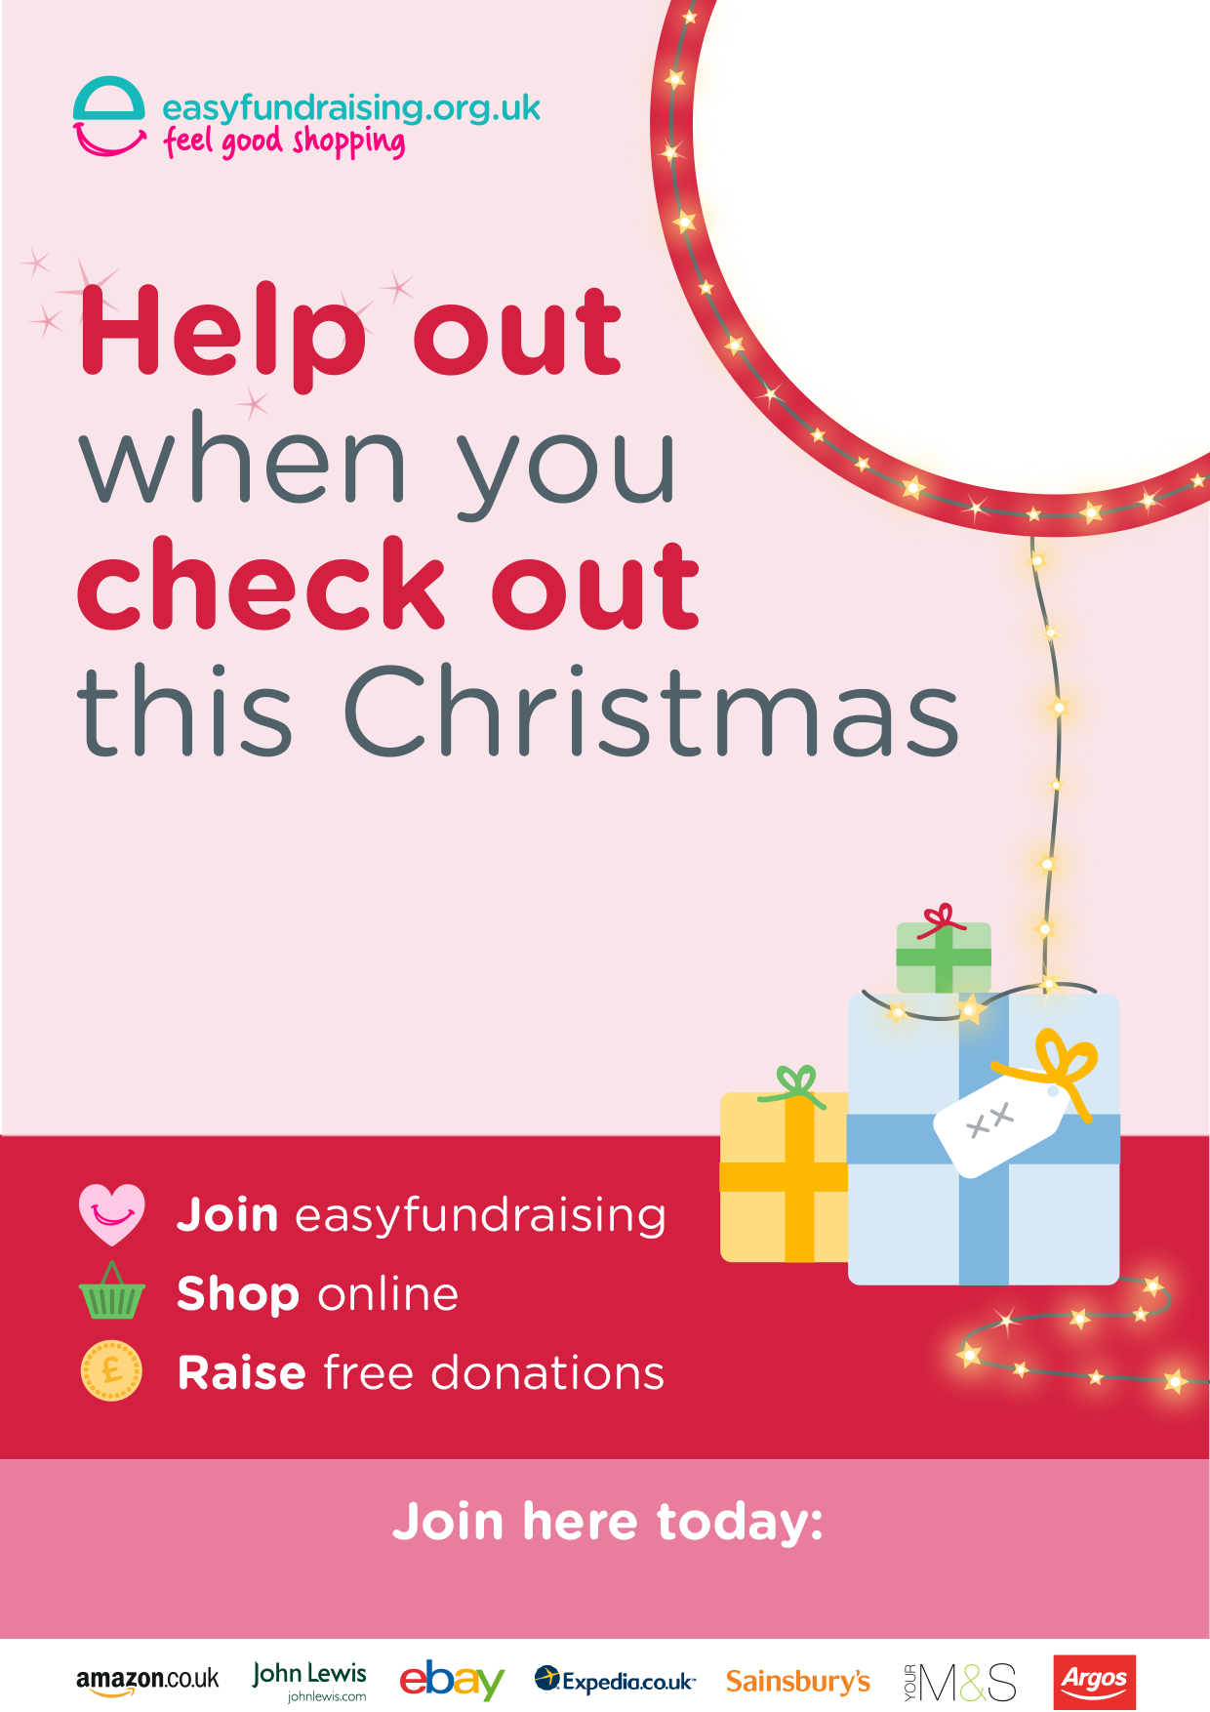

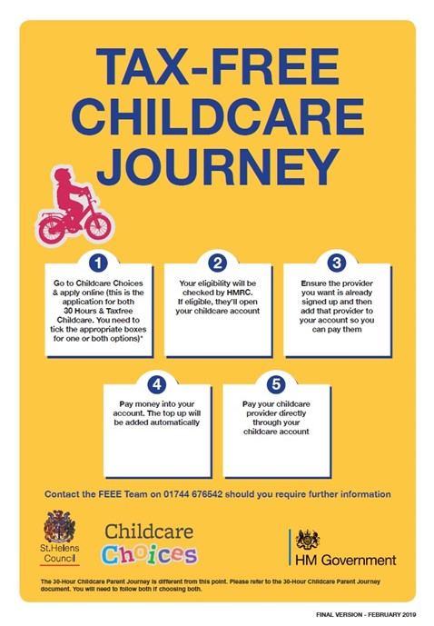

Uniform

If you would like to purchase any of our St-Andrews Pre-School uniform please visit
https://www.shopkeepeasy.com/990059371

